Week03 – Short Paper Assignment – SCRUM

SWEN 603 9041

Debashis Jena

University of Maryland Global Campus

# Introduction

Agile method is one of the iterative development models which came in the late 1990s and early 2000s. As it follows the principles of Agile manifesto, it gradually started getting the popularity and the use of the methods gradually became higher and higher. As the method evolved, many of the variants of this methodology came into the picture. These types can be mainly classified as follows.

1. Scrum
2. Extreme programming
3. Kanban
4. Lean development
5. Other hybrid methods

Each of these methods has its usability and apt for a certain scenario. However, one of the studies in 2014 by Stavru compared three case studies between 2011 and 2014 found that up to 83% of the users used Scrum as their agile method.

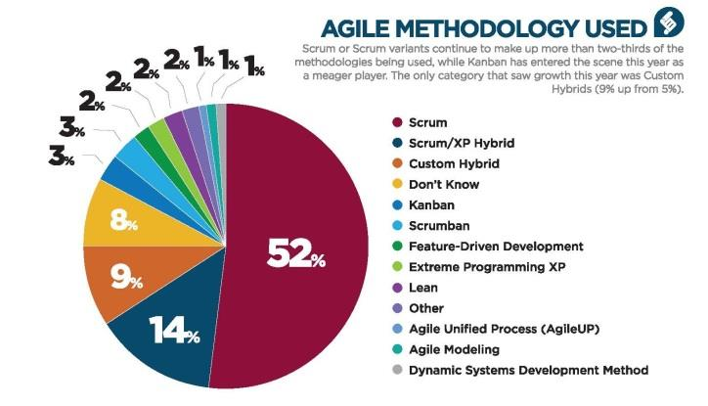

This was very much in line with the study done by VersionOne in the year 2011 which said 52% of the agile implementors use Scrum mechanism for their development process. The above piechart by VersionOne contains the percentage breakdown of the Agile method used.

# What is Scrum?

Scrum is a basic framework that defines the roles and organizes the actionable work and helps the teams effectively prioritize and complete the work selected. Scrum makes the process transparent for the internal team and the external users. Everybody can observe if the team is making any tangible progress or not. If required any additional methods can be applied which compliments the current process.

Just like any other iterative development methods, Scrum works incrementally. Roles in this process are limited and there are no management layers. Scrum encourages to have a self-organizing team which makes the development team accountable for their work. In the case of the scrum, each of the team members has a lot more freedom to pick and choose the work they want to do in a short period.

As Mark Layton takes an analogy, scrum is just like a game of rugby and in fact, the term "Scrum" comes from the game itself which means huddle. “Huddles or scrums are formed with the forwards from one side interlocking their arms, heads down, and pushing against the forwards from the opposing team, also interlocking arms heads down. The ball is then thrown into the midst of this tightly condensed group of athletes. Although each team member plays a unique position, all play both attacking and defending roles, and work as a team to move the ball down the field of play.” (Layton, 2015). To explain this analogy more, the scrum process has basic principles, daily activities and defined roles to work with. Just like the huddle, a sprint starts with a group meeting called Planning, in which the team decides how much work the team can finish in a defined period. Once the planning meeting is finished, the goal of the team becomes to finish the work they have signed up for. As the team players in the game, in case of Scrum development, each of the team members have their unique role to play in the sprint, each of them possesses varying talent and knowledge from different domains. They all come together with one common goal in mind, which is to finish the job on time.

Roles within Scrum can be classified and explained as follows.

1. Product Owner – may be one of the users or even a stakeholder. The product owner is the one who decides what work needs to be completed and sets the priority of the work.
2. Scrum master – coordinates meetings including daily standup. Responsible for clearing any impedances or blockage for the development team. Work closely with both the product owner and the development team.
3. Development team – the core team which decides the work they wont to work in a sprint and finish at the end of the iteration.

The requirements for a product are split into multiple smaller size requirements and then to granular stories. Stories usually have the following sections.

1. Summary – short description from the user perspective
2. Description – elaborated description of the story
3. Acceptance criteria – the criteria which will state the story is completely implemented and ready for release

Artifacts in a scrum can be categorized as below.

1. Product backlog – the entire set of stories which define the whole product
2. Sprint backlog – the defined set of stories picked to be worked in a sprint

Ceremonies in a sprint can be as follows:

1. Sprint planning – A sprint starts with a defined sprint backlog in a planning meeting which may last for multiple hours. This is where the team discusses among themselves about the "How" part of each of the stories.
2. Development – Typically, the stories are not preassigned to any of the developers. They are self-picked by the developer as the sprint progresses.
3. Daily standup – A daily 15 minutes meeting where each developer states the below points
   1. What I did yesterday
   2. What I am going to do today
   3. What are my blockers
4. Backlog grooming – A meeting where the future stories are discussed within the team. The “What” part of the story is discussed here.
5. Sprint Review and Demo – A demo to the users/stakeholders. Potentially deployable or shippable product.
6. Sprint Retrospective – The review of the past sprint works. Mainly the below items are discussed.
   1. What went well and should continue
   2. What can be better
   3. Action items or guidelines to be followed in the future

# Pros and Cons of Scrum

As the main principle of agile is to accept change, Scrum allows you to adopt the change requests, technological constraints, and the innovations very quickly. Apart from this, there are many advantages to scrum.

Advantages:

* Adaptable planning framework – As the scrum is known for, the changes are welcome. Unlike the traditional method, the initial plan is never concrete. The plan may completely be changed as per the project requirements.
* Adaptable requirements model – In scrum, the requirements are written to be negotiable between the developers and the product owners, by adding, removing or changing the scope of the requirements.
* Emphasis on self-organizing teams – The self-organization, in the case of Scrum is given more emphasis than any other variants of agile method. As discussed earlier, the stories are not pre-assigned, they are picked voluntarily by the developers.

Disadvantages:

* Limited time for code reviews or inspections – Even though some development team keeps some room for code reviews and inspections, but sometimes the process demands continuous delivery, leaving less room for some of the preventive validations.
* No comprehensive testing methodology – Unlike waterfall models, Scrum does not have a specific and formal quality assurance method. The applications are tested as they are completed, with no or limited test scripts and plans.

# References

1. Layton, Mark C.. (2015). *Scrum for dummies.* Retrieved *from http://library.books24x7.com.ezproxy.umuc.edu/toc.aspx?bookid=82533.*
2. Rico, David F. & Sayani, Hasan H. & Sone, Saya. (2009). *The business value of agile software methods: maximizing ROI with just-in-time processes and documentation.* Retrieved from *http://library.books24x7.com.ezproxy.umuc.edu/toc.aspx?bookid=37804.*
3. Vanker, C.. (2015). *The Adoption of Agile Software Development Methodologies by Organisations in South Africa*. Retrieved from https://www.researchgate.net/publication/303200204_The_Adoption_of_Agile_Software_Development_Methodologies_by_Organisations_in_South_Africa